EXP.NO-1 | Web Page Creation using HTML

AIM:
To create a web page that embeds a map with hotspots, frames, and links. The web page should be designed using HTML, incorporating embedded, external, and inline CSS for styling. This exercise aims to enhance understanding of integrating multimedia elements like maps, creating interactive hotspots, and organizing content using frames while applying different CSS techniques for styling.
ALGORITHM:
Create the HTML structure:
- Set up the basic HTML document with <!DOCTYPE html>, <html>, <head>, and <body> tags.
- In the <head>, link the external CSS file (<link> tag), define the title, and include any metadata.
- In the <body>, create the necessary elements:
  - Frames: Use the <frameset> tag to create a frame layout (for older browsers, use <iframe> instead).
  - Map: Use the <img> tag to display a map.
  - Hotspots: Create clickable regions using the <map> and <area> tags.
  - Links: Add hyperlinks (<a>) to navigate to different parts of the page or external sites.
Create CSS Styles:
- External CSS: In a separate file, define styles such as colors, fonts, and layout for the entire page.
- Inline CSS: Use the style attribute within specific tags to apply styles (e.g., in <div> or <p> tags).
- Embedded CSS: Inside the <style> tag in the <head>, define styles for specific elements like the map, frames, and text.
Map with Hotspots:
- Use the <map> tag to create an image map.
- Define the <area> tag for each hotspot, specifying the coordinates (e.g., coords="x,y,x2,y2") for clickable areas on the map.
Frames:
- Use the <iframe> tag for embedding external content like a map or another webpage, with attributes such as src for the URL, width, and height.
Add Links:
- Inside the <body>, use the <a> tag to create links for navigation (for example, to link to specific parts of the page or external sites).
Test the Page:
- Test the webpage to check the functionality of frames, hotspots, and links. Ensure that the map hotspots are clickable and the linked content displays correctly.
- Ensure that the styles are applied properly using inline, embedded, and external CSS.
CODE:
EXPT-1.html
<!DOCTYPE html>
<html>
<head>
<title>CompareHub</title>
<!-- EXTERNAL CSS -->
<link rel="stylesheet" href="styles.css">
<!-- EMBEDDED CSS -->
<style>
.note {
color: #555;
font-size: 14px;
}
</style>
</head>
<body>
<header class="site-header">
<a href="exp1.html" class="logo">
CompareHub
</a>
<nav class="nav-links">
<a href="phones.html">Smartphones</a>
<a href="laptops.html">Laptops</a>
</nav>
</header>

<section class="row">

<div class="left">
<h2>Browse Categories</h2>
<img src="catagories.png"
usemap="#categorymap"
width="100%"
alt="Electronics Categories">
<map name="categorymap">
<area shape="poly"
coords="83,199,270,92,325,239,155,362"
href="laptops.html"
target="_self"
alt="Laptops"
title="View Laptops">
<area shape="poly"
coords="415,54,488,56,475,217,404,212"
href="phones.html"
target="_self"
alt="Smartphones"
title="View Smartphones">
</map>
<p class="note">Click a category to view products</p>
</div>

<div class="right">
<h2>Featured Products</h2>
<div class="grid">
<div class="card">
<h3>iPhone 14</h3>
<p class="price">₹70,000</p>
<p>Add to Compare</p>
</div>
<div class="card">
<h3>Samsung S23</h3>
<p class="price">₹65,000</p>
<p>Add to Compare</p>
</div>
<div class="card">
<h3>Dell XPS</h3>
<p class="price">₹95,000</p>
<p>Add to Compare</p>
</div>
</div>
</div>
</section>

<section>
<h2>Find Nearby Electronics Stores</h2>
<iframe
src="https://www.google.com/maps?q=electronics+store&output=embed"
width="100%" height="300">
</iframe>
</section>
</body>
</html>
Laptops.html
<!DOCTYPE html>
<html>
<head>
<title>Laptops | ElectroCompare</title>
<!-- External CSS -->
<link rel="stylesheet" href="styles.css">
<!-- Embedded CSS (page-specific) -->
<style>
.page-title {
margin: 20px 30px;
color: #1f2937;
}
.back-link {
margin: 20px 30px;
display: inline-block;
text-decoration: none;
color: #2563eb;
font-weight: bold;
}
</style>
</head>
<body>
<header class="site-header">
<a href="exp1.html" class="logo">TechScope</a>
<nav class="nav-links">
<a href="phones.html">Smartphones</a>
<a href="laptops.html">Laptops</a>
</nav>
</header>
<h2 class="page-title">Laptops</h2>
<section>
<div class="grid">
<div class="card">
<img src="macbook.jpg" width="180" alt="MacBook Air">
<h3>MacBook Air</h3>
<p class="price">₹1,10,000</p>
<p>Apple M1 • 8GB RAM • macOS</p>
<div class="compare-box">
<label>
<input type="checkbox">
Add to Compare
</label>
</div>
</div>
<div class="card">
<img src="dell.jpg" width="180" alt="Dell XPS">
<h3>Dell XPS 13</h3>
<p class="price">₹95,000</p>
<p>Intel i7 • 16GB RAM • Windows</p>
<div class="compare-box">
<label>
<input type="checkbox">
Add to Compare
</label>
</div>
</div>
<div class="card">
<img src="hp.jpg" width="180" alt="HP Spectre">
<h3>HP Spectre</h3>
<p class="price">₹1,00,000</p>
<p>Intel i7 • 16GB RAM • Windows</p>
<div class="compare-box">
<label>
<input type="checkbox">
Add to Compare
</label>
</div>
</div>
</div>
</section>
<a href="exp1.html" class="back-link">← Back to Categories</a>
</body>
</html>
Phones.html
<!DOCTYPE html>
<html>
<head>
<title>Smartphones | ElectroCompare</title>
<link rel="stylesheet" href="styles.css">
<style>
.page-title {
margin: 20px 30px;
color: #1f2937;
}
.back-link {
margin: 20px 30px;
display: inline-block;
text-decoration: none;
color: #2563eb;
font-weight: bold;
}
</style>
</head>
<body>
<header class="site-header">
<a href="exp1.html" class="logo">TechScope</a>
<nav class="nav-links">
<a href="phones.html">Smartphones</a>
<a href="laptops.html">Laptops</a>
</nav>
</header>
<h2 class="page-title">Smartphones</h2>
<section class="grid">
<div class="card">
<img src="iphone.jpg" width="180">
<h3>iPhone 14</h3>
<p class="price">₹70,000</p>
<p>A15 Bionic • iOS</p>
<div class="compare-box">
<label>
<input type="checkbox">
Add to Compare
</label>
</div>
</div>
<div class="card">
<img src="samsung.jpg" width="180">
<h3>Samsung S23</h3>
<p class="price">₹65,000</p>
<p>Snapdragon • Android</p>
<div class="compare-box">
<label>
<input type="checkbox">
Add to Compare
</label>
</div>
</div>
</section>
<a href="exp1.html" class="back-link">← Back to Categories</a>
</body>
</html>
OUTPUT:
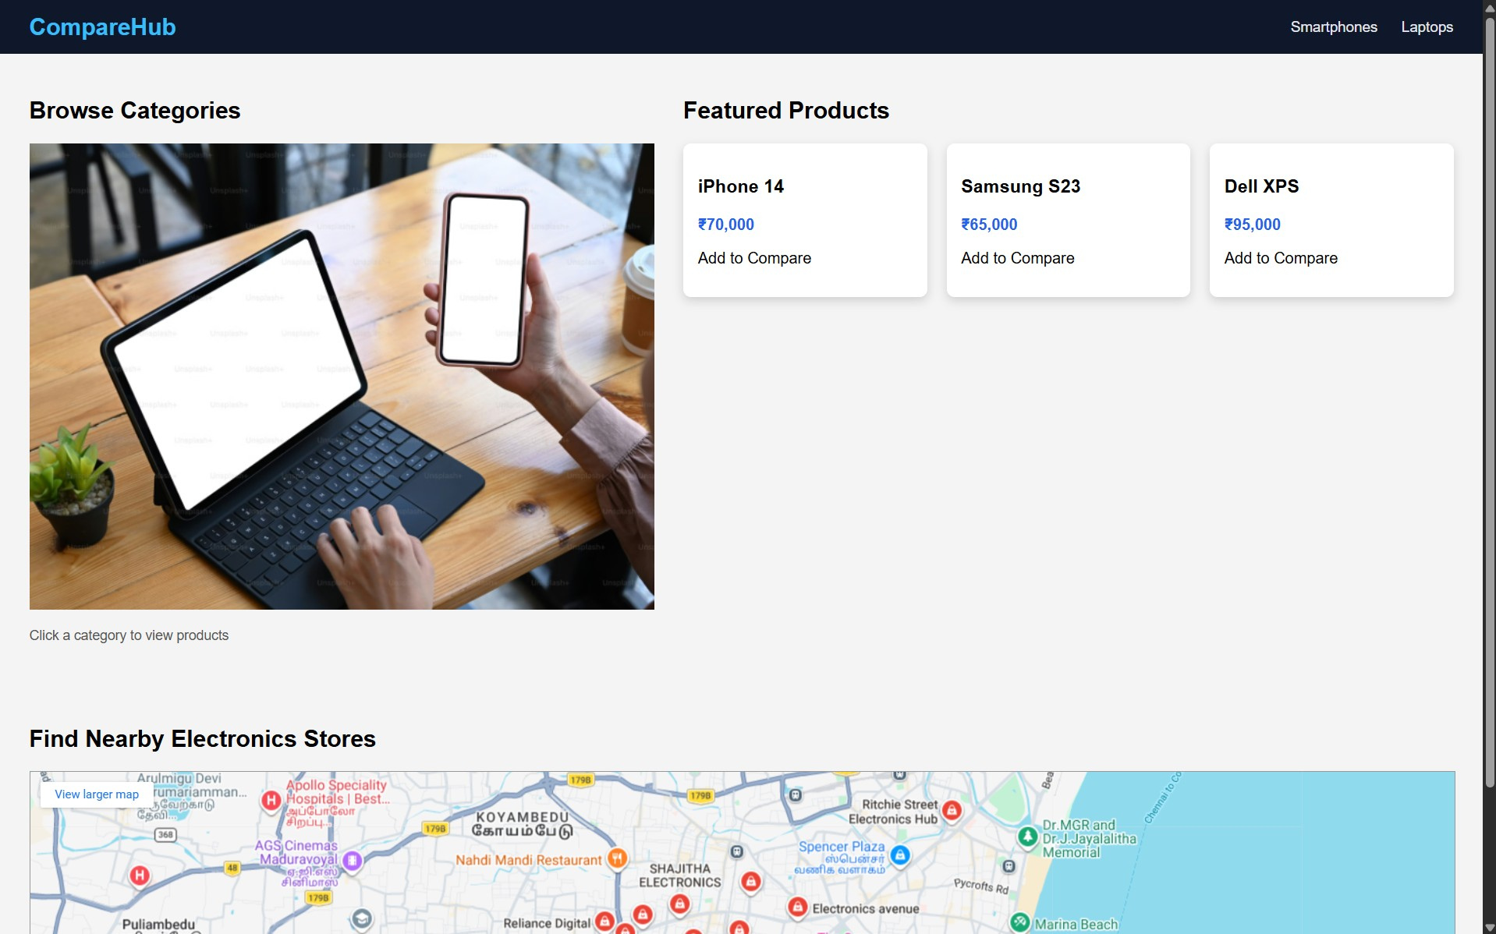
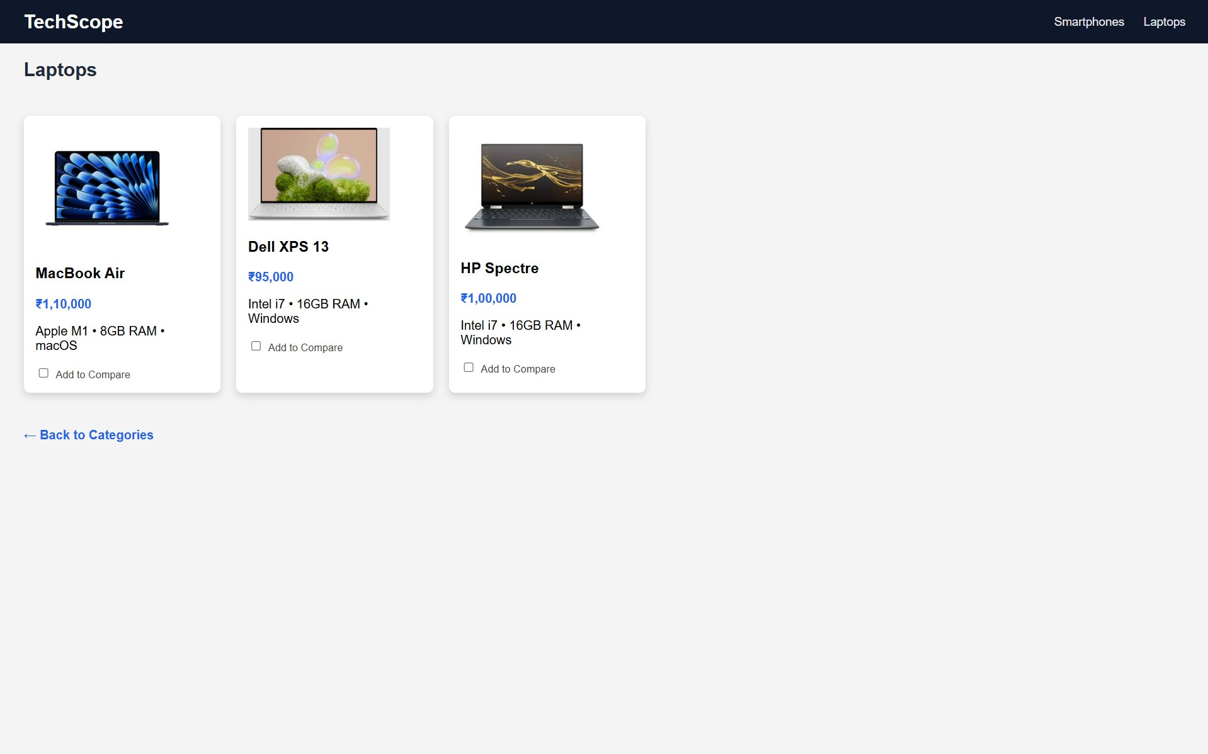
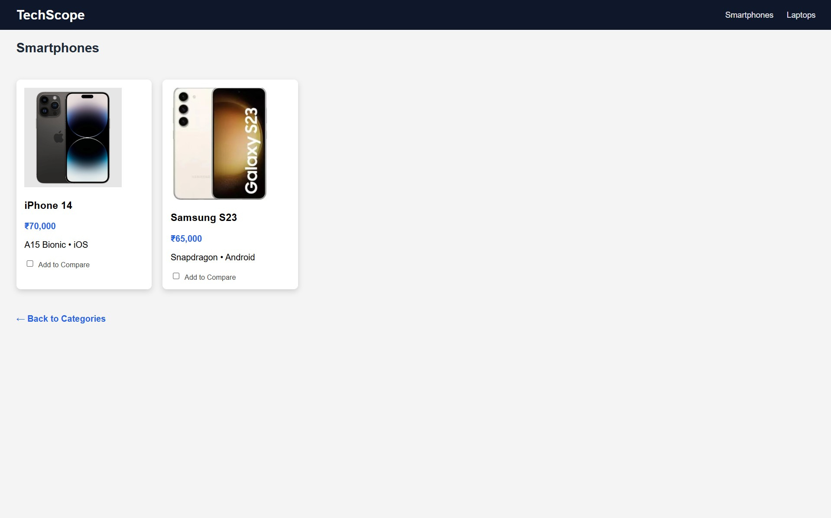
RESULT:
Html Page is created with embedded map along with hot spot, frames & links.

